**A Data Analysis Report on Power Bi**

SHOPNEST STORE CAPSTONE

**Submitted** ***By:***

***Jyoshna Maruvada***

**Dashboard: -**

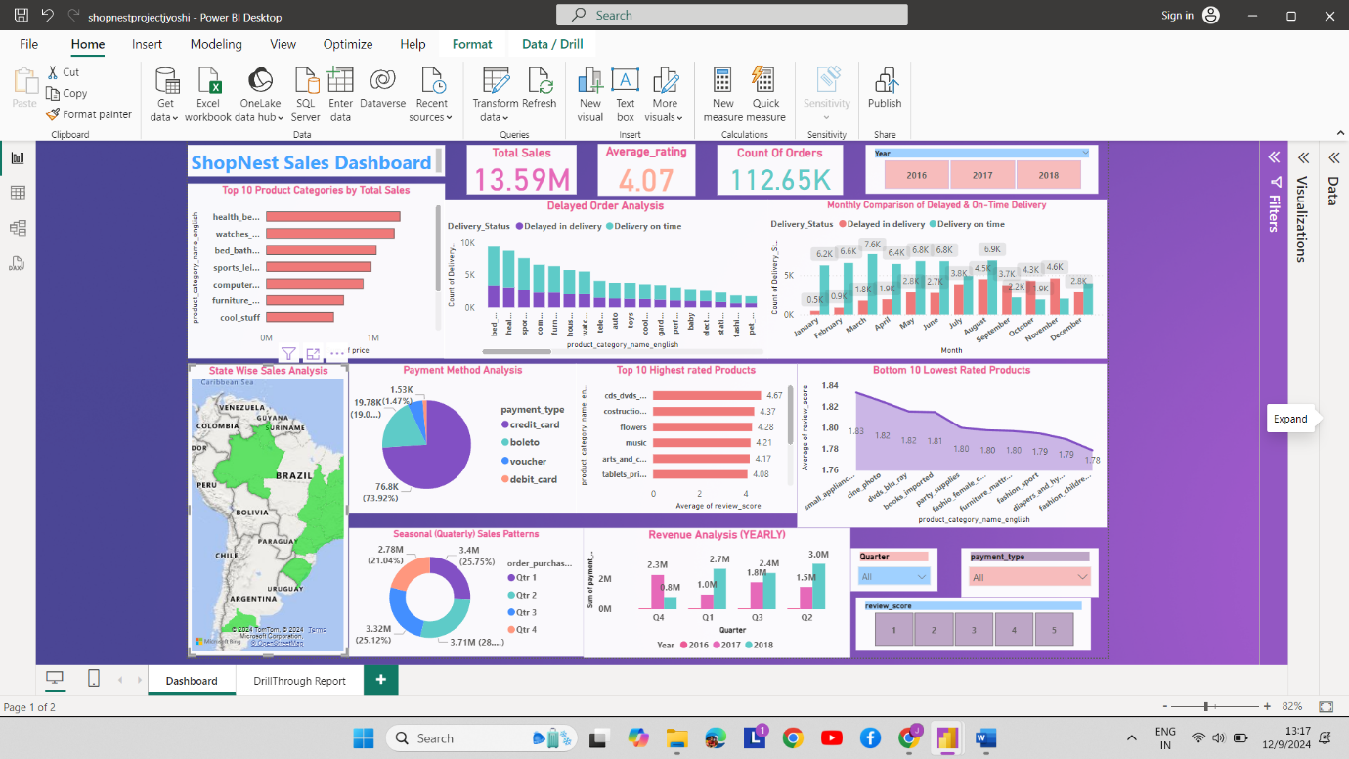

**The ShopNest Sales Dashboard provides a comprehensive overview of the store’s performance across key metrics, enabling data-driven decision-making. It captures total sales, average ratings, and the count of orders, giving stakeholders an overall snapshot of business health.**

**Key sections include delayed order analysis, where the number of delayed deliveries is tracked, helping identify potential bottlenecks in logistics. A breakdown of top product categories by sales reveals the store’s most profitable items, while an analysis of state-wise sales highlights geographical performance trends. Pie charts for payment method analysis shed light on customer preferences for transactions, aiding financial planning and system optimization.**

**This visually engaging and interactive dashboard empowers ShopNest to monitor its performance effectively and focus on enhancing customer experience, operational efficiency, and revenue growth.**

**Relationships Between Tables: -**

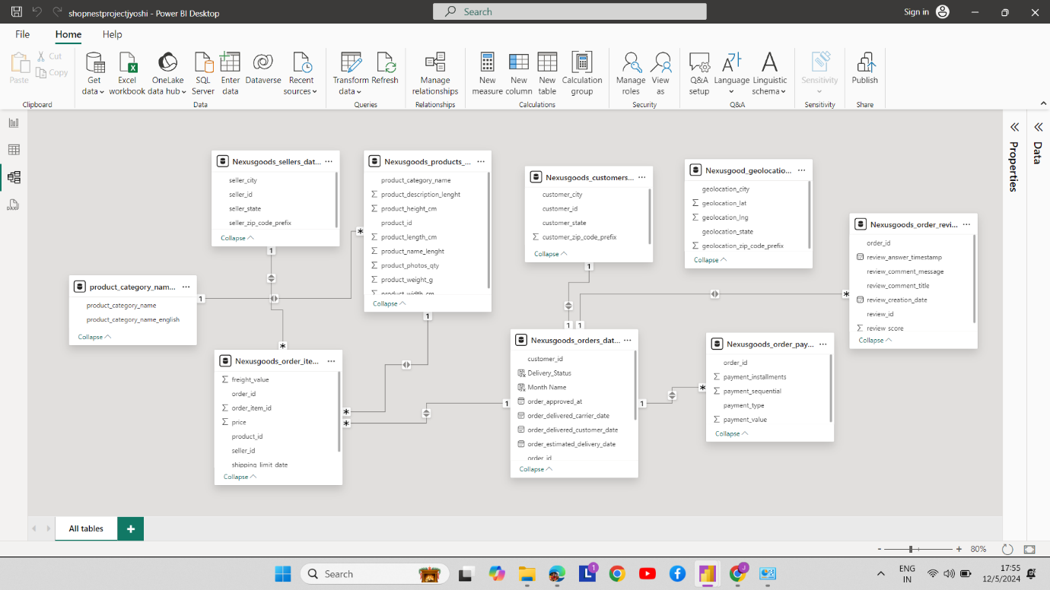

**In Power BI, relationships between tables are crucial for building a cohesive and functional data model, enabling effective visual representation. These relationships define how data in one table is connected to data in another, allowing for seamless interaction and accurate aggregation across multiple datasets.**

**Power BI supports different types of relationships, including one-to-many, one-to-one, and many-to-many. Defining these relationships ensures that visuals such as charts, graphs, and slicers are synchronized and provide meaningful insights.**

**Relationships also support cross-filtering, where filters applied to one table automatically impact connected tables. This dynamic interaction is essential for creating dashboards with interdependent visuals, like filtering sales by region or customer.**

**A well-designed data model with properly defined relationships enhances report accuracy, reduces redundancy, and improves query performance, making it a fundamental step in the Power BI workflow.**

**Top 10 Categories by Total Price:**

Identify and visually reprsent the Top 10 categories by Total Price

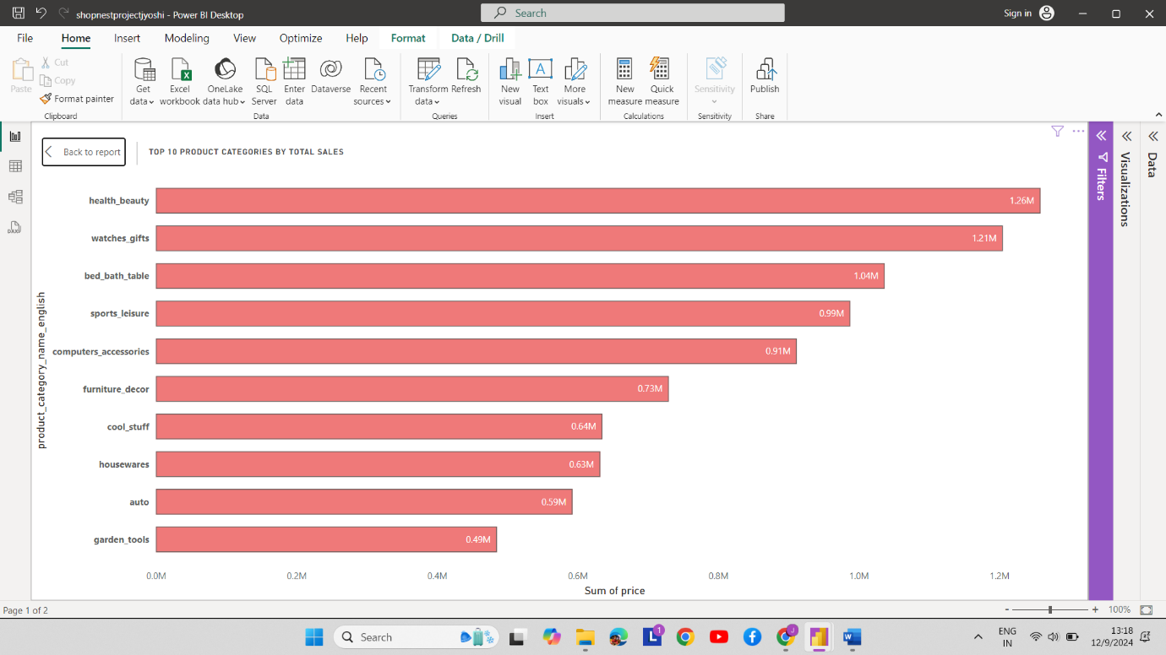

**Explanation:**

The ShopNest Sales Dashboard provides a clear breakdown of the top 10 product categories by total sales. Leading the chart, health beauty dominates with a remarkable **1.26M** in sales, closely followed by watches gifts at **1.21M.** These figures suggest a strong consumer preference for personal care and gift items. Categories like bed_bath_table **(1.04M)** and sports_leisure **(0.95M)** also show significant traction, indicating high demand for home essentials and recreational goods.

Interestingly, computers accessories and furniture decor demonstrate steady sales figures at **0.91M** and **0.73M**, respectively, pointing to consistent interest in tech and home enhancement products. However, categories like auto **(0.59M)** and garden tools **(0.49M)** show relatively lower sales, suggesting room for growth in these segments.

This analysis reveals valuable insights into customer preferences, highlighting opportunities for targeted marketing and inventory optimization to maximize revenue in high-demand categories.

**Delayed Order Analysis**

Determine the number of Orders in each category. An Order is considered Delayed if the actual delivery date is later than the estimated delivery date

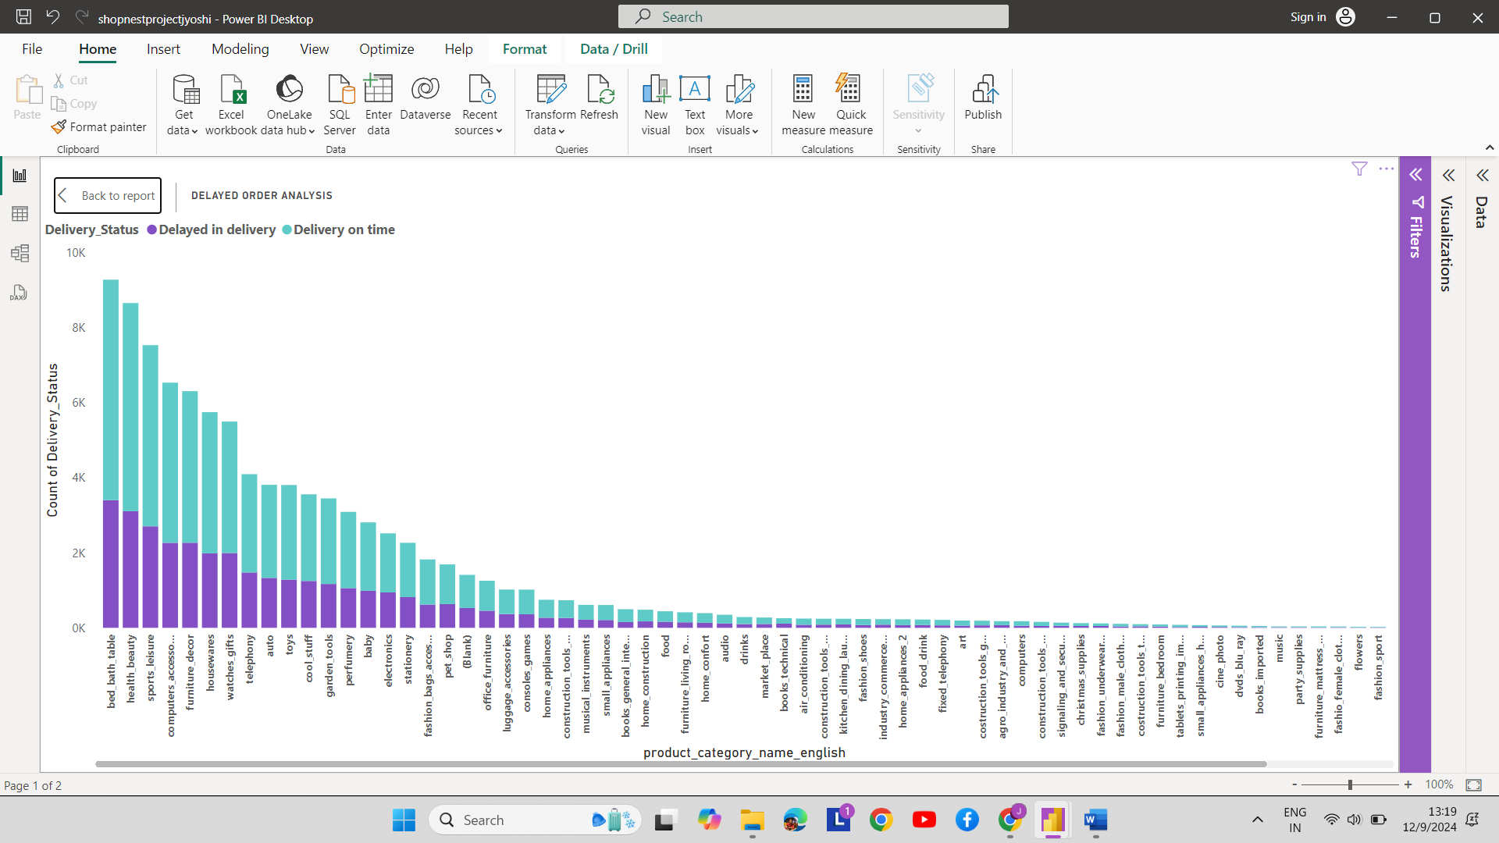

**Explanation:**

This chart focuses on **“Delayed Order Analysis”** by product category for the Shopnest store. Categories such as “bed bath table,” “kitchen appliances,” and “computer accessories” stand out with the highest number of delayed deliveries (light blue bars). This indicates a logistical challenge in handling bulky or high-demand items, which could be due to supply chain inefficiencies, warehouse processing delays, or transportation bottlenecks. On the other hand, categories like “books and magazines” and “music” have minimal delays, likely because they are lightweight and easier to manage.

The key challenge lies in ensuring timely delivery for bulkier and more complex categories, which require more resources and coordination. Addressing this issue may involve streamlining warehouse operations, enhancing inventory forecasting, or improving last-mile delivery processes. By focusing on these high-delay categories, the store could reduce customer complaints and enhance overall satisfaction

**Monthly Comparison of Delayed and On-Time Orders**

Create a dynamic visual that compares the number of delayed orders to the number of orders received earlier for each month. Utilize the drill through cross-report feature to provide a detailed analysis of late and on-time deliveries.

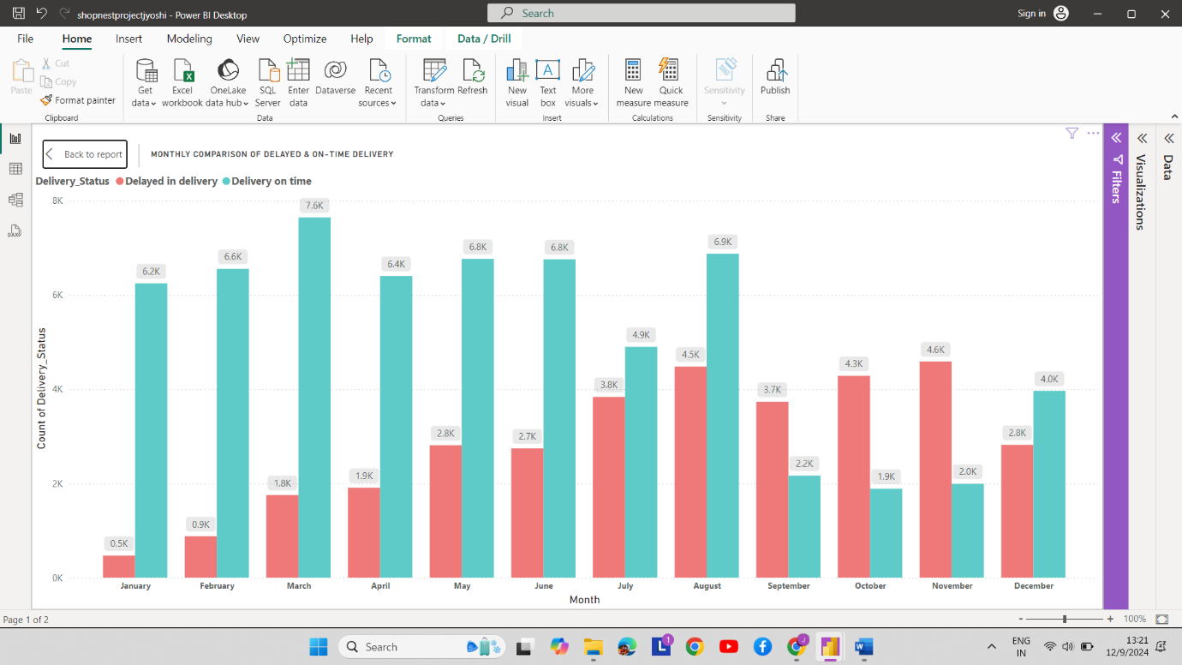

**Explanation:**

This chart provides **a “Monthly Comparison of Delayed and On-Time Deliveries”** for the Shopnest store. While the majority of deliveries are on time (dark blue bars), certain months, such as May, June, and August, show a noticeable increase in delayed deliveries (pink bars). This suggests that these months face significant operational challenges. These delays could be attributed to seasonal spikes in demand, resource shortages, or transportation constraints. For example, May and June might coincide with peak shopping periods, while August could reflect challenges like weather disruptions or workforce issues.

The challenge lies in ensuring operational efficiency during high-demand months. By leveraging the **drill-through feature**, Shopnest can pinpoint problem areas, such as specific product categories, regions, or warehouses contributing to delays. Addressing these root causes through better demand planning, resource allocation, and targeted process improvements can significantly reduce delays and enhance the overall customer experience.

**Payment Method Analysis:**

Analyze the most frequently used payment methods by customers using a visually appealing representation, such as a pie chart or other suitable visuals.

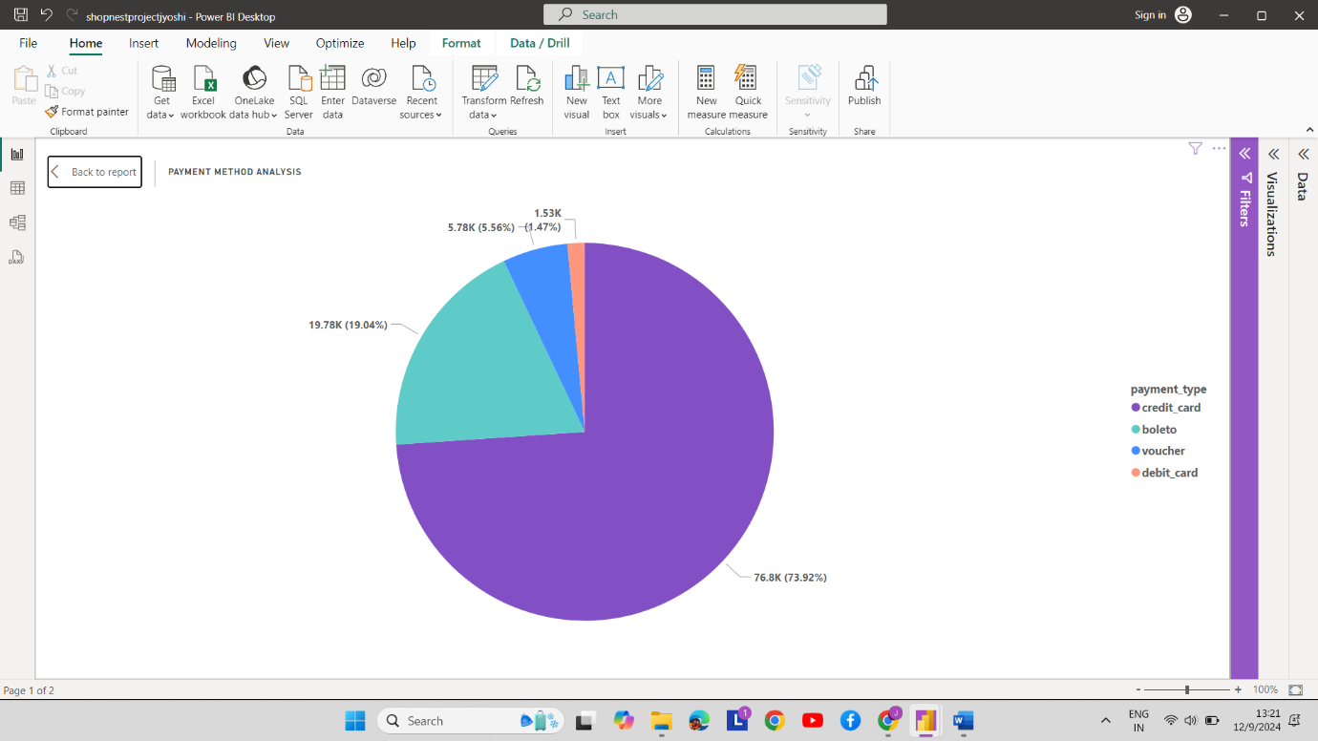

**Insights on Payment Method Analysis:**

The pie chart provides an overview of the distribution of payment types used at the Shopnest store:

**1. Credit Card (72.92%):**

The majority of customers prefer using credit cards for their purchases. This indicates trust in the platform’s payment security and possibly the ease of processing transactions through credit cards. Promotions such as reward points or cashback offers might also be influencing this preference.

**2. Boleto (19.94%):**

Boleto, a popular payment method in some regions, accounts for a significant portion of transactions. Its prominence suggests that many customers may prefer offline or alternative banking methods, highlighting the need to maintain and streamline this option.

**3. Debit Card (5.54%):**

Debit cards are the third most-used payment method, indicating that some customers prefer direct payment from their accounts. However, the relatively low percentage suggests credit cards dominate for flexibility or benefits.

**4. Voucher (1.47%):**

Vouchers represent a niche category, likely driven by promotional campaigns or gift card usage. Expanding voucher-based offers could attract more customers in this segment.

This payment distribution emphasizes the importance of maintaining diverse and seamless payment options to cater to all customer preferences.

**Product Rating Analysis:**

Determine the top 10 highest-rated products and the bottom 10 lowest-rated products using a bar or column chart.

**Top 10 Highest rated Products**

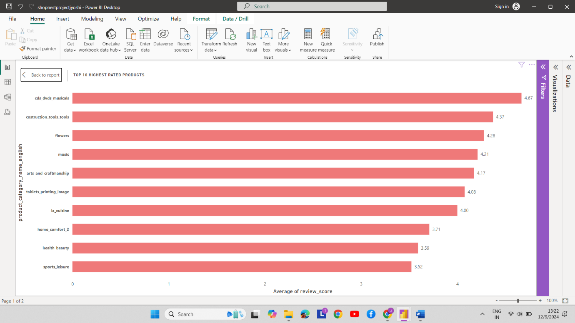

**Explanation:**

This chart showcases the top 10 highest-rated product categories based on their average review scores, with “CDs, DVDs, Musicals” leading at 4.67. Categories such as “Construction Tools,” “Flowers,” and “Music” follow closely, indicating that they resonate well with customers, likely due to quality, fulfilment of expectations, or niche appeal.

Lower-ranked categories like “Sports and Leisure” and “Health and Beauty” (around 3.5 average rating) might be impacted by variability in product quality or mismatched customer expectations.

Such analysis is crucial for businesses to understand customer satisfaction trends, prioritize popular product categories, and identify areas needing improvement. The chart suggests potential focus areas for maintaining high satisfaction, such as sustaining quality in top-rated categories and addressing concerns in lower-rated ones.

**Bottom 10 Least Rated Products**

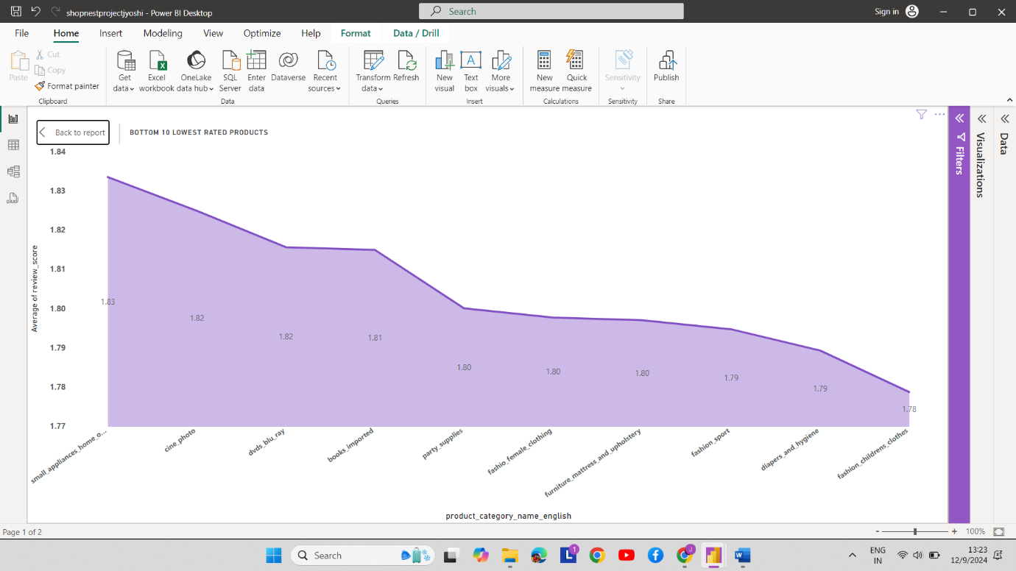

**Explanation:**

This chart displays the bottom 10 lowest-rated product categories based on their average review scores, ranging from 1.83 to 1.78. Categories like “Small Appliances for Home” and “Cine-Photo” lead this list, but the consistent low ratings suggest customer dissatisfaction across these categories. Factors such as poor quality, unmet expectations, or misleading product descriptions may contribute to these ratings.

Lower scores in categories like “Fashion Children’s Clothes” and “Clothing and Accessories” may indicate sizing inconsistencies or material quality concerns. Additionally, “Furniture” and “Books Imported” could face challenges related to delivery damage or cultural relevance.

This analysis can guide businesses to investigate root causes of customer dissatisfaction and take corrective actions, such as improving quality control, refining product descriptions, or addressing logistical issues, to enhance customer trust and satisfaction.

**State-wise Sales Analysis:**

Identify and visually represent states with high and low sales, providing a clear understanding of regional sales performance.

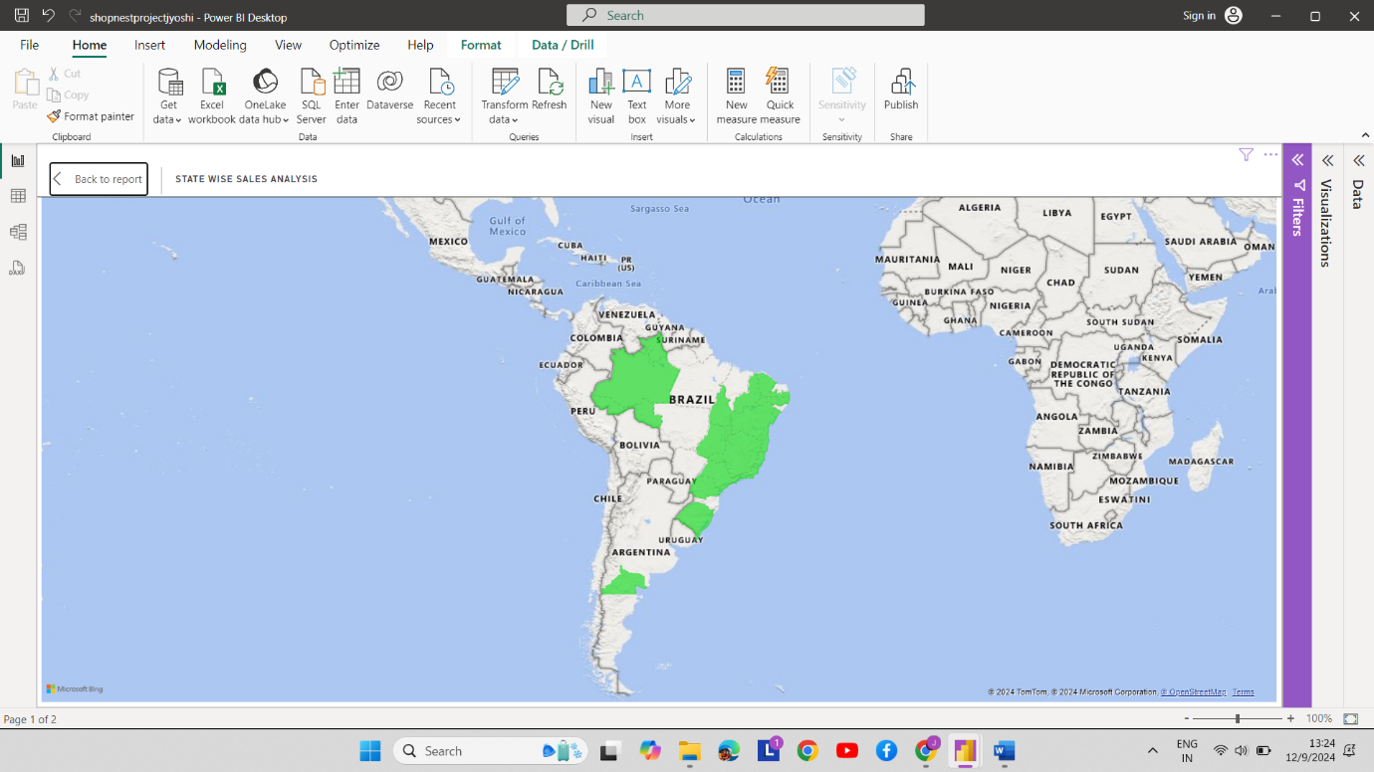

**Explanation:**

This chart shows a state-wise breakdown of total sales (sum of price) across different regions. The state **“SP”** significantly outpaces others, contributing the highest sales, followed by states like **“RJ,” “MG,”** and **“RS.”** The steep drop-off after the top states highlights a concentration of sales activity in a few key regions, likely driven by population density, higher purchasing power, or urbanization.

States with lower sales, such as **“TO,” “AM,”** and **“AP,”** may reflect smaller populations, limited market penetration, or logistical challenges affecting product availability. Additionally, the presence of a blank category suggests some data may be missing or unclassified, which could skew overall insights.

This analysis helps businesses identify high-performing regions to focus marketing and inventory efforts while addressing barriers in underperforming areas to expand their reach and optimize sales distribution.

**Seasonal Sales Patterns:**

Investigate and visualize any seasonal patterns (Quarterly) or trends in sales data over the course of the year.

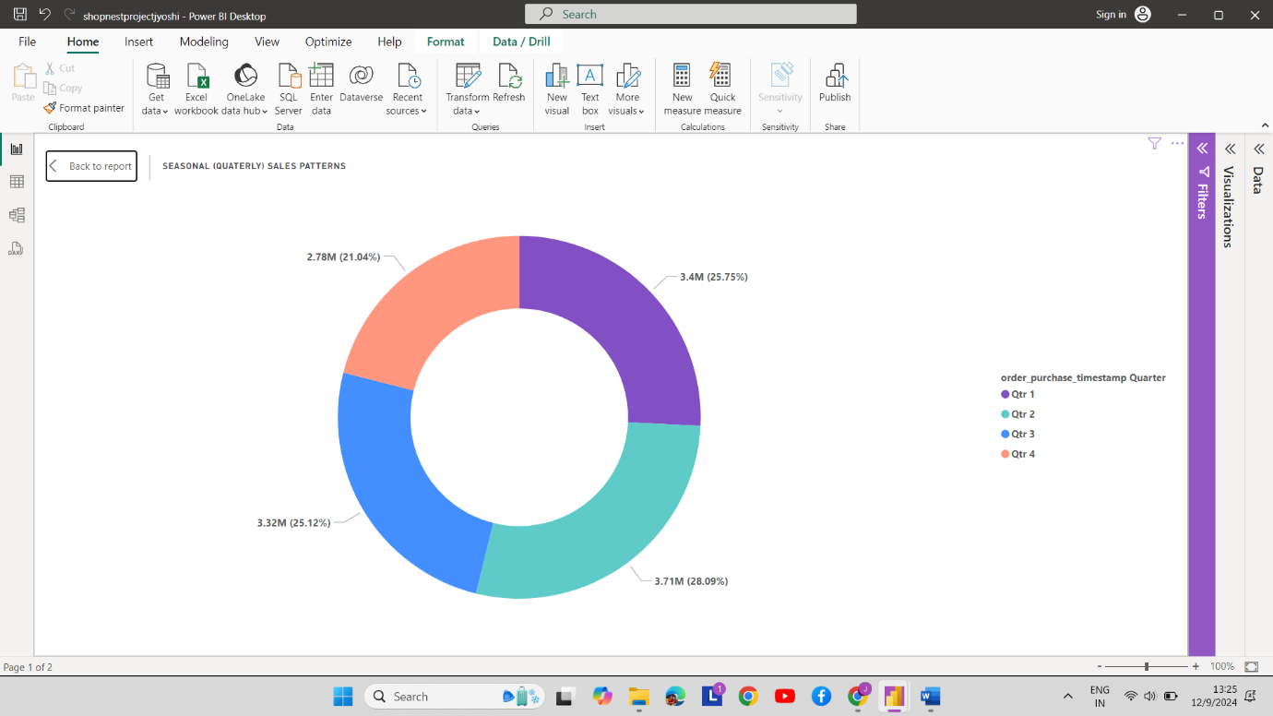

The chart is a donut chart created in Power BI, which represents seasonal quarterly sales patterns, divided into four quarters (Qtr 1 to Qtr 4). Here are insights and possible reasons, categorized by quarter:

**Quarterly Insights:**

**1. Qtr 1 (Blue - 25.75%, 3.4M)**:

**Insights:** This quarter has the second-highest sales percentage.

**Possible Reasons:**

• Post-holiday shopping or new year sales promotions.

• Seasonal demand for products like winter-related goods.

• Increased marketing campaigns or early-year planning.

**2. Qtr 2 (Orange - 25.12%, 3.32M):**

**Insights:** Sales slightly dropped compared to Qtr 1 but remain consistent overall.

**Possible Reasons:**

• Transition period between seasons with moderate demand.

• Launch of new products during spring or pre-summer.

• Stable performance across most regions or categories.

**3. Qtr 3 (Purple - 21.04%, 2.78M):**

**Insights:** This is the lowest-performing quarter.

**Possible Reasons:**

• Summer vacations may reduce consumer spending in some regions.

• Non-essential purchases decline due to travel or leisure priorities.

• Inventory clearance might occur, impacting revenue growth.

**4. Qtr 4 (Red - 28.09%, 3.71M):**

**Insights:** The highest-performing quarter.

**Possible Reasons:**

• Holiday season sales and festive shopping sprees.

• Black Friday, Cyber Monday, or year-end discounts boosting revenue.

• Higher demand for gifting, apparel, and seasonal products.

**Overall Suggestions:**

• Focus marketing and promotional activities to boost Qtr 3 performance.

• Leverage data from Qtr 4 for strategizing future campaigns.

• Analyze customer trends across regions to maximize returns in Qtr 1 and Qtr 2.

**Revenue Analysis:**

Determine the total revenue generated by ShopNest Store and analyze how it changes over time (Yearly). Represent this information through suitable visuals to highlight trends and patterns.

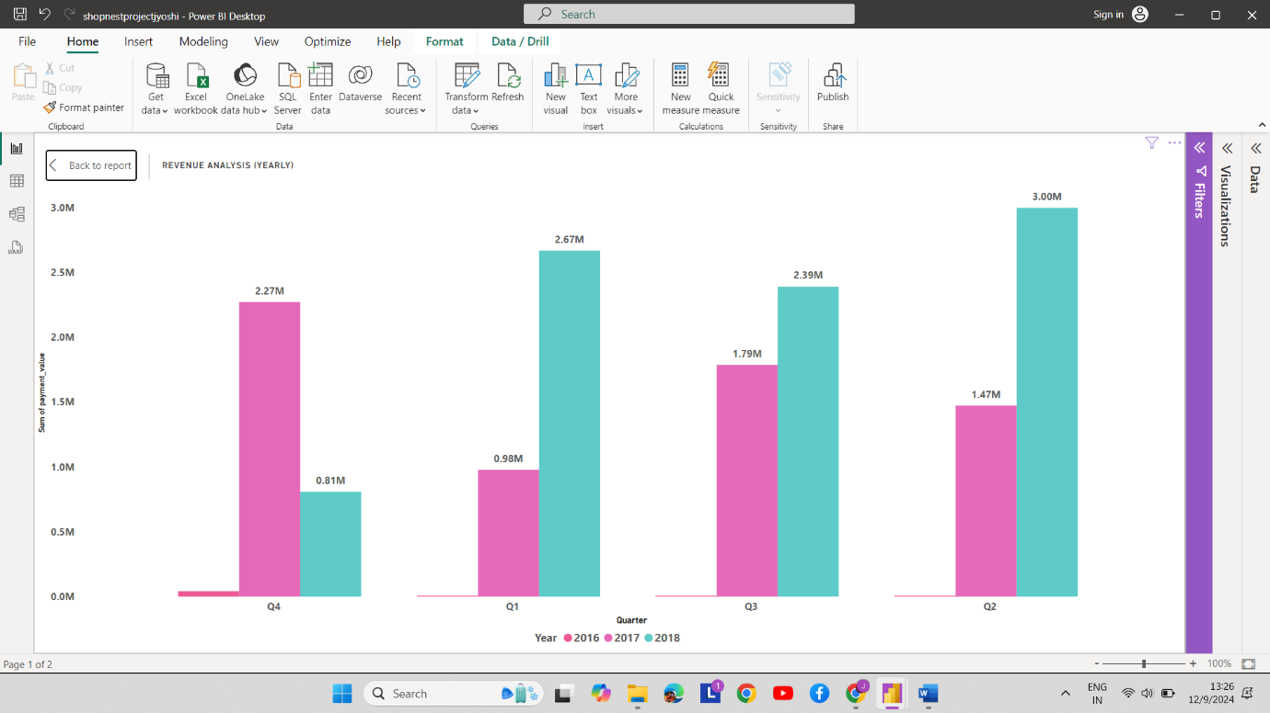

**2016 (Yellow Bars):**

**Insights:**

• Very minimal revenue contribution compared to other years.

• Only visible in Q4 with negligible revenue (likely less than 1M).

**Possible Reasons:**

• The business could have started towards the end of 2016.

• Limited operations, lower market presence, or initial challenges.

• No significant marketing efforts or fewer customer acquisitions during this period.

**2017 (Pink Bars):**

**Insights:**

• Noticeable growth across all quarters compared to 2016.

• Q4 (2.27M) stands out as the highest revenue quarter.

• Q3 (1.79M) and Q2 (1.47M) show consistent growth.

• Q1 (0.81M) is the lowest-performing quarter.

**Possible Reasons:**

• Business expansion and better customer engagement starting in 2017.

• Q4 might have benefited from holiday sales or promotions.

• Q2 and Q3 could represent steady operational and seasonal demand.

• Q1 might reflect a post-holiday slowdown or lower marketing activities early in the year.

**2018 (Blue Bars):**

**Insights:**

• Consistently higher revenues across all quarters compared to 2017.

• Q2 (3.00M) is the best-performing quarter.

• Q4 (2.6M) follows closely, with Q3 (2.39M) maintaining strong results.

• Q1 (0.98M) remains the weakest but shows slight improvement over 2017.

**Possible Reasons:**

• Stronger brand positioning, customer loyalty, and optimized operations.

• Q2 growth might result from targeted campaigns, new product launches, or favourable seasonal trends.

• Q4’s holiday-driven sales continue to perform well but do not surpass Q2.

• Early-year Q1 might still be a challenge due to customer spending patterns.

**Overall Trends:**

1. Steady growth from 2016 to 2018, indicating effective strategies and scaling.

2. Q2 and Q4 are consistently strong quarters, suggesting significant seasonal or promotional impacts.

3. Q1 remains the lowest-performing quarter, possibly due to post-holiday lulls or lower consumer spending.